**Phuc Le**

**Student ID: 012360751**

**CS 151, Spring 2018**

**Professor: Dr. Kim**

**Programming Assignment 2**

1. **A set of use cases**

Use cases: Load events file into the calendar

|  |  |  |
| --- | --- | --- |
| Steps | User's action | System's Response |
| 1 |  | System show the menu:  Select one of the following options:  [L]oad [V]iew by [C]reate, [G]o to [E]vent list [D]elete [Q]uit |
| 2 | Enter “L” |  |
| 3 |  | System will load all events into the calendar if the file exists. Otherwise it will show error |

Use cases: View Event by day

|  |  |  |
| --- | --- | --- |
| Steps | User's action | System's Response |
| 1 |  | System show the menu:  Select one of the following options:  [L]oad [V]iew by [C]reate, [G]o to [E]vent list [D]elete [Q]uit |
| 2 | Enter “V” |  |
| 3 |  | [D]ay view or [M]view ? |
| 4 | Enter “D” |  |
| 5 |  | System print out the events of current day and menu:  [P]revious or [N]ext or [M]ain menu ? |
| 6 | Enter “P” |  |
| 7 |  | System print out the events of previous day and menu:  [P]revious or [N]ext or [M]ain menu ? |
| 8 | Enter “N” |  |
| 9 |  | System print out the events of previous day and menu:  [P]revious or [N]ext or [M]ain menu ? |
| 10 | Enter “M” | System go back to main menu.  [L]oad [V]iew by [C]reate, [G]o to [E]vent list [D]elete [Q]uit |

Use cases: View event by month

|  |  |  |
| --- | --- | --- |
| Steps | User's action | System's Response |
| 1 |  | System show the menu:  Select one of the following options:  [L]oad [V]iew by [C]reate, [G]o to [E]vent list [D]elete [Q]uit |
| 2 | Enter “V” |  |
| 3 |  | [D]ay view or [M]view ? |
| 4 | Enter “M” |  |
| 5 |  | System print out month view with highlighted event-day with {} and menu:  [P]revious or [N]ext or [M]ain menu ? |
| 6 | Enter “P” |  |
| 7 |  | System print out previous month view with highlighted event-day with {} and menu:  [P]revious or [N]ext or [M]ain menu ? |
| 8 | Enter “N” |  |
| 9 |  | System print out next month view with highlighted event-day with {} and menu:  [P]revious or [N]ext or [M]ain menu ? |
| 10 | Enter “M” | System go back to main menu.  [L]oad [V]iew by [C]reate, [G]o to [E]vent list [D]elete [Q]uit |

Use cases: Create Event

|  |  |  |
| --- | --- | --- |
| Steps | User's action | System's Response |
| 1 |  | System show the menu:  Select one of the following options:  [L]oad [V]iew by [C]reate, [G]o to [E]vent list [D]elete [Q]uit |
| 2 | Enter “C” |  |
| 3 |  | System ask user to enter date of the new event as MM/DD/YYYY |
| 4 | Enter date in format MM/DD/YYYY |  |
| 5 |  | System ask user if the event has ending time |
| 6 | Enter “yes” or “no” |  |
| 7 |  | System ask user to enter time as HH:MM( or HH:MM:HH:MM if has ending time) |
| 8 | Enter the starting time (and ending time) |  |
| 9 |  | System ask user to enter name of event |
| 10 | Enter name for event |  |
| 11 |  | System check if event is duplicate or not. If it duplicates, then go back step 1 |
| 12 |  | System will show that the event has been successfully added or Event is duplicate. If it is duplicate, User will be ask to enter all information again. |

Use cases: See events on particular day

|  |  |  |
| --- | --- | --- |
| Steps | User's action | System's Response |
| 1 |  | System show the menu:  Select one of the following options:  [L]oad [V]iew by [C]reate, [G]o to [E]vent list [D]elete [Q]uit |
| 2 | Enter “G” |  |
| 3 |  | System will ask user to enter the date in form MM/DD/YYYY |
| 4 | Enter date in form MM/DD/YYYY |  |
| 5 |  | System will display all events happen during that day |

Use cases: See all events in the calendar

|  |  |  |
| --- | --- | --- |
| Steps | User's action | System's Response |
| 1 |  | System show the menu:  Select one of the following options:  [L]oad [V]iew by [C]reate, [G]o to [E]vent list [D]elete [Q]uit |
| 2 | Enter “E” |  |
| 3 |  | System show all events in the calendar sorted by the furthest event. |

Use cases: Delete events

|  |  |  |
| --- | --- | --- |
| Steps | User's action | System's Response |
| 1 |  | System show the menu:  Select one of the following options:  [L]oad [V]iew by [C]reate, [G]o to [E]vent list [D]elete [Q]uit |
| 2 | Enter “D” |  |
| 3 |  | System will ask user to enter the date in form MM/DD/YYYY |
| 4 | Enter date in form MM/DD/YYYY |  |
| 5 |  | System will display all events happen during that day and ask if you want to delete all or just selected event:  [S]elected and [A]ll. |
| 6 | If Enter “a” |  |
| 7 |  | System will delete all events in that day. |
| 8 | If Enter “s” |  |
| 9 |  | System will display events on that day with number in front of it. User asked to enter the number of event to be deleted. |
| 10 | Enter “i” |  |
| 11 |  | System will delete event ith in that day. |

Use cases: Quit and save all events to file

|  |  |  |
| --- | --- | --- |
| Steps | User's action | System's Response |
| 1 |  | System show the menu:  Select one of the following options:  [L]oad [V]iew by [C]reate, [G]o to [E]vent list [D]elete [Q]uit |
| 2 | Enter “Q” |  |
| 3 |  | System will show that all events has been saved to events.ser |

1. **A set of CRC cards**

|  |  |
| --- | --- |
| MyCalendarTester | |
| Display calendar by month and day  Display and interact with user by menu  Get user input date  Get user input time  Get user input name of event | Event  MyCalendar |

|  |  |
| --- | --- |
| Event | |
| Provide Name  Provide Ending time  Provide Starting time  Provide Date | MyCalendar  MyCalendarTester |

|  |  |
| --- | --- |
| MyCalendar | |
| Add event  Delete event  Delete all events  Delete all events in day  Display all events  Provide list of all events  Provide list of all events in day | Event  MyCalendarTester |

1. **UML class diagram**

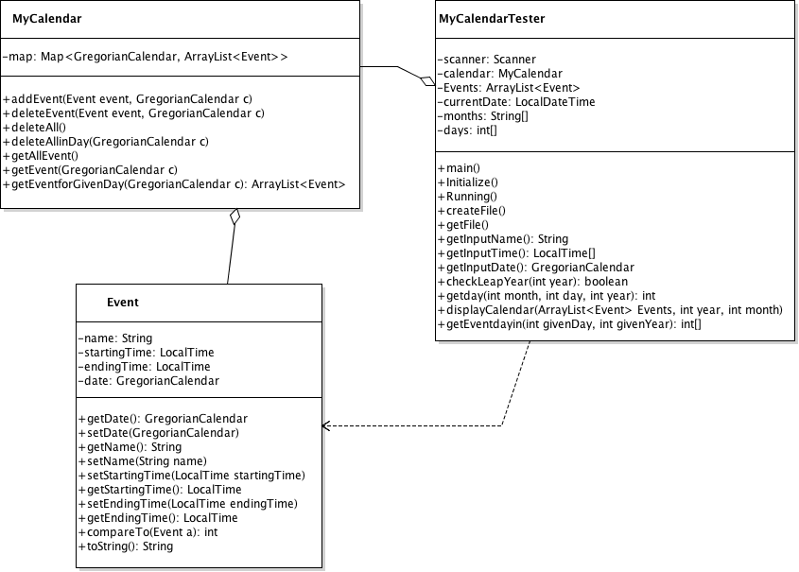

1. **Sequence diagram for the "to create an event"**

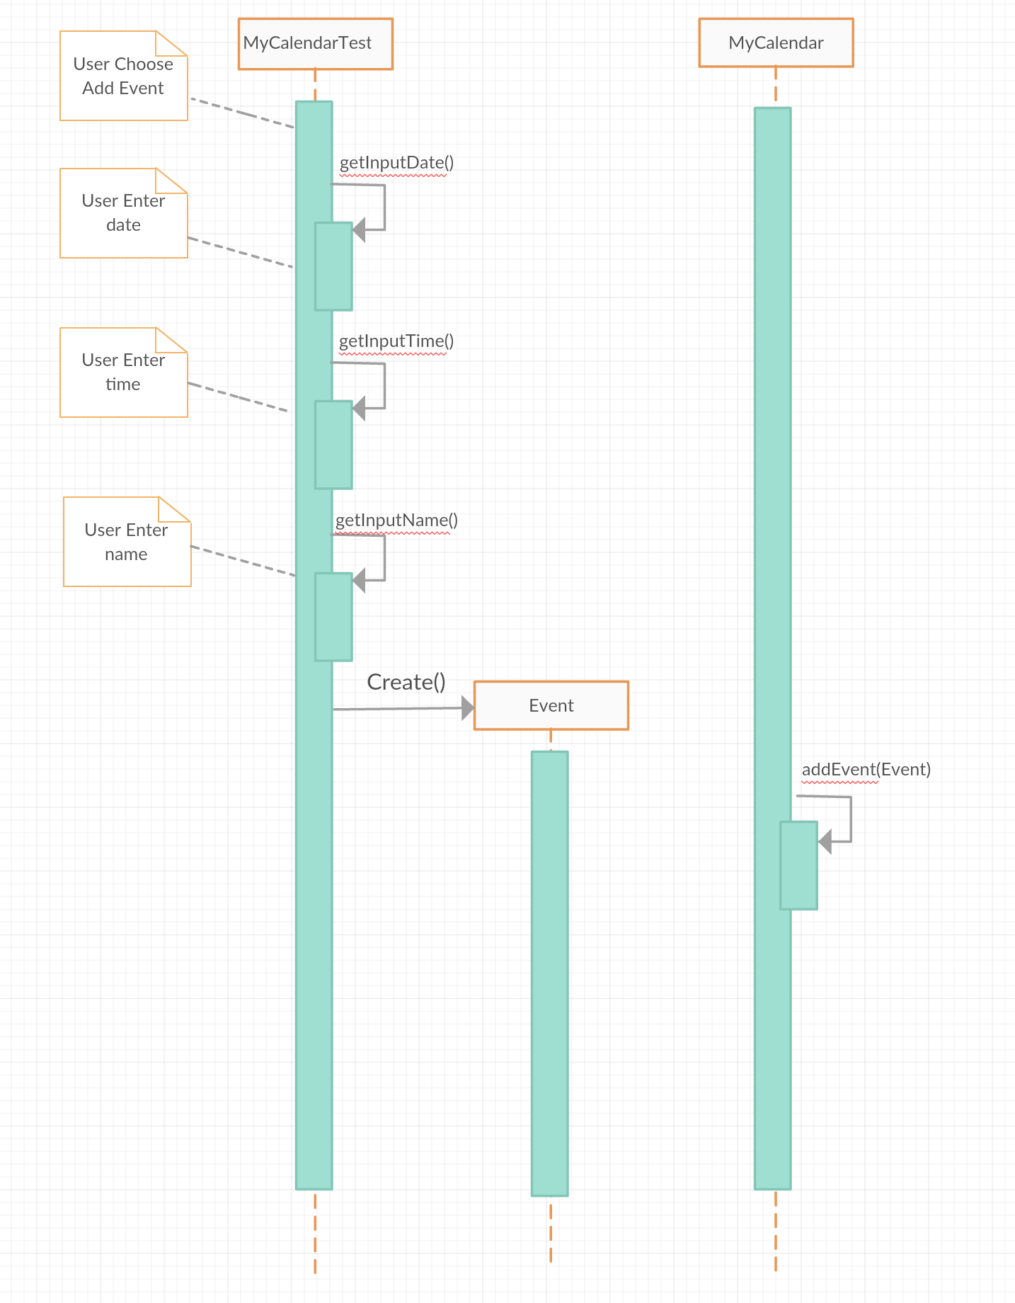

1. **Screenshots of usages**

Screen 1: Show the initial calendar after starting the application

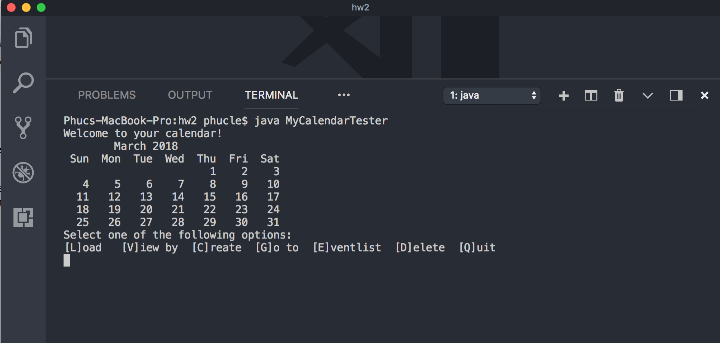

Screen 2: [L]oad your events.txt and show [E]vent list

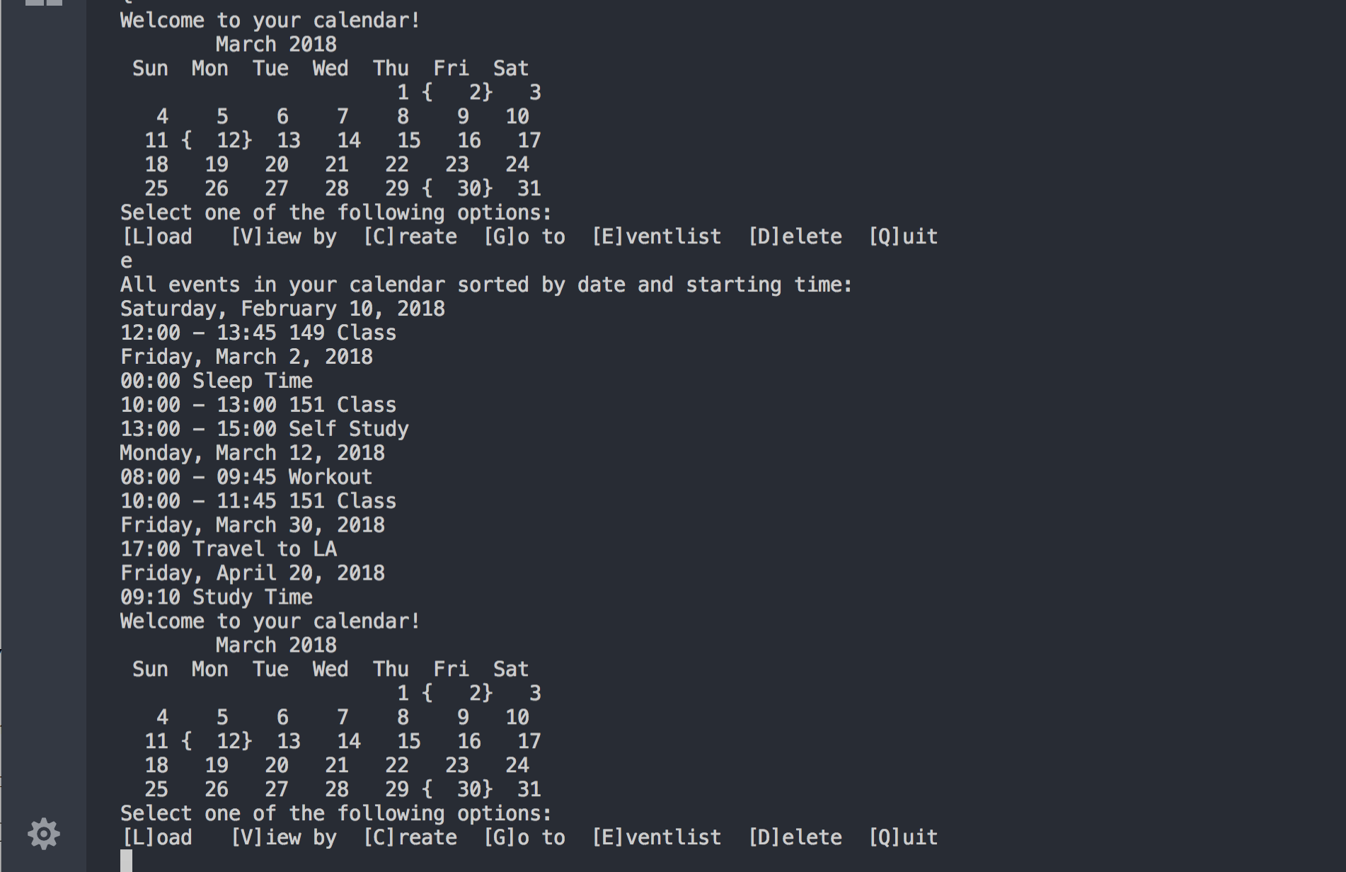

Screen 3: Select [V]iew by and choose the Day view and show the current Day view.

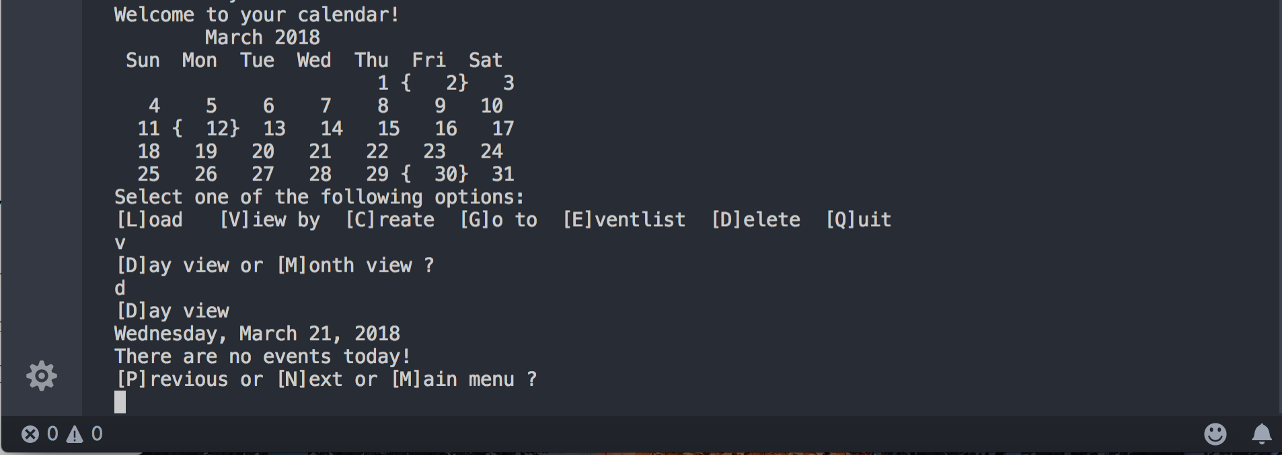

Screen 4: From the Day view, press [P]revious and show the previous day.

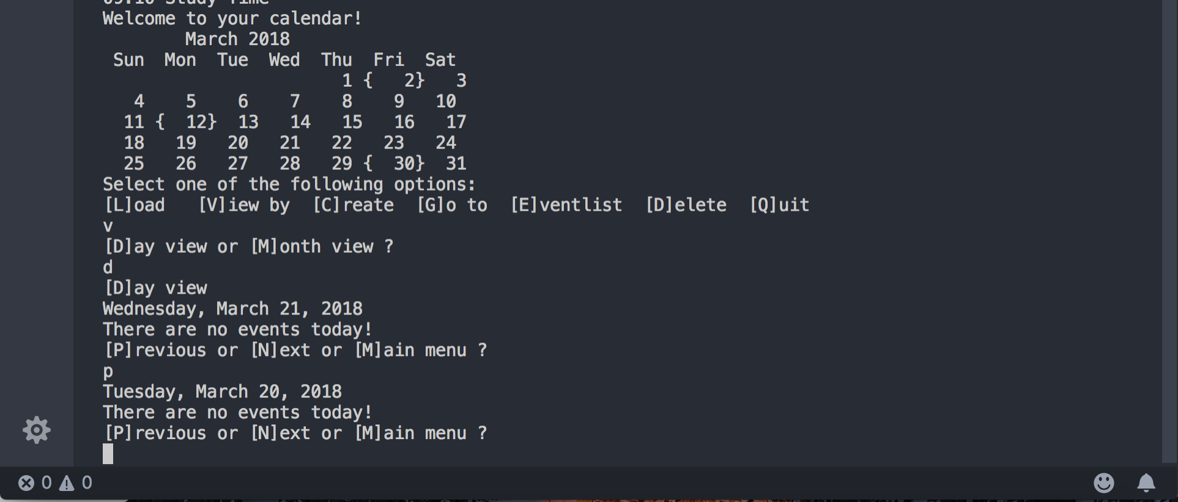

Screen 5: From the previous view, press [N]ext THREE times and show the next day. 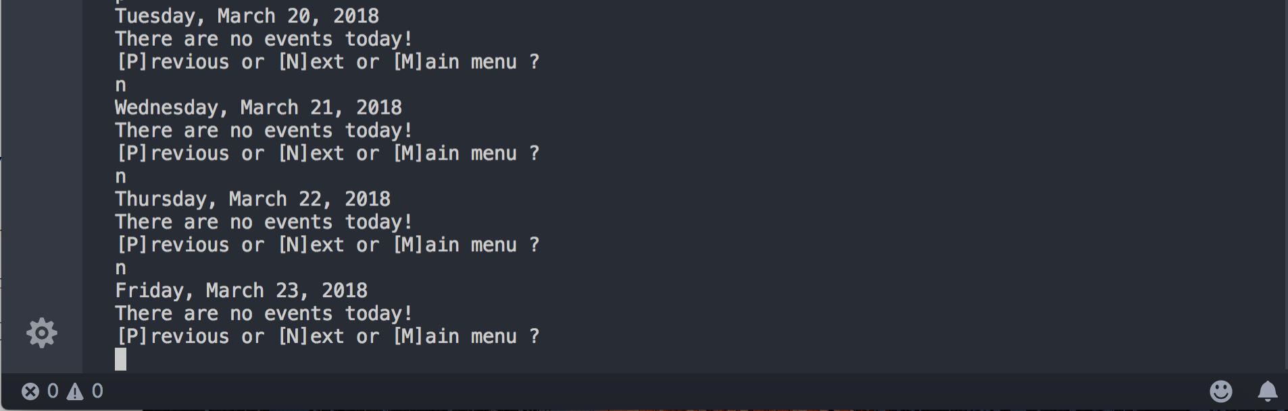

Screen 6: Move the Day view to show a day with an event.

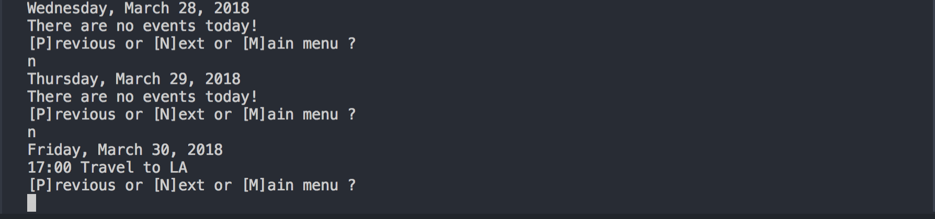

Screen 7: Select [M]ain menu and select [V]iew by and [M]onth view and show the current Month view.

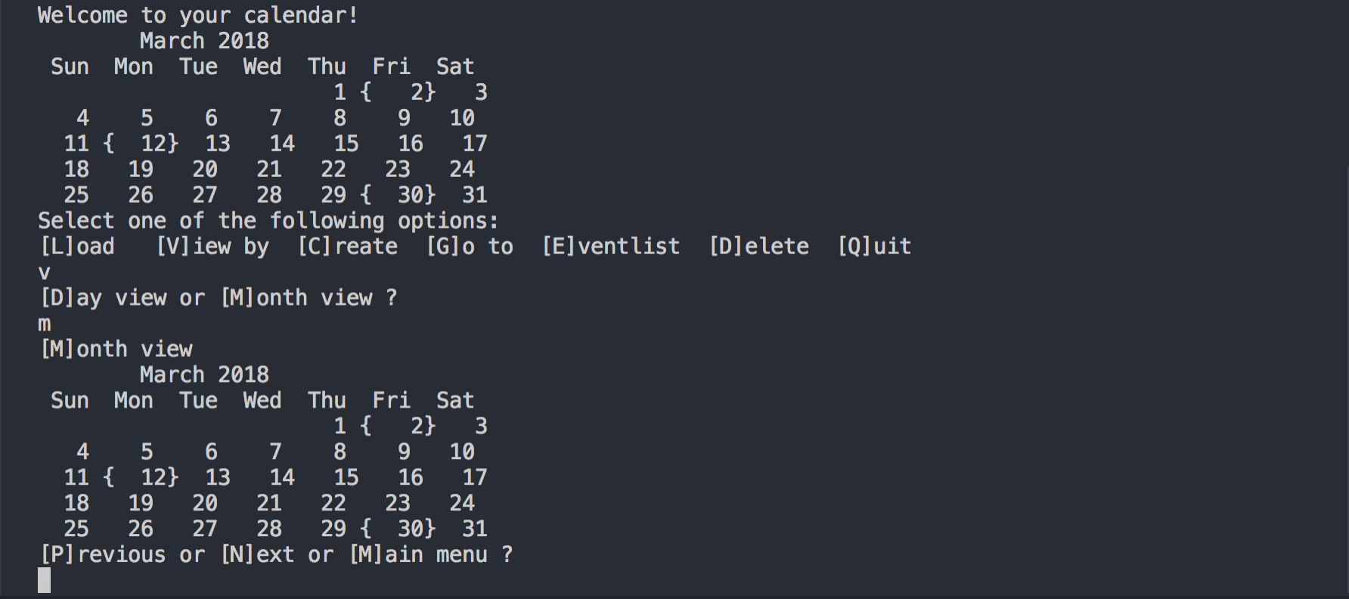

Screen 8: Move the Month view to show a month with an event.

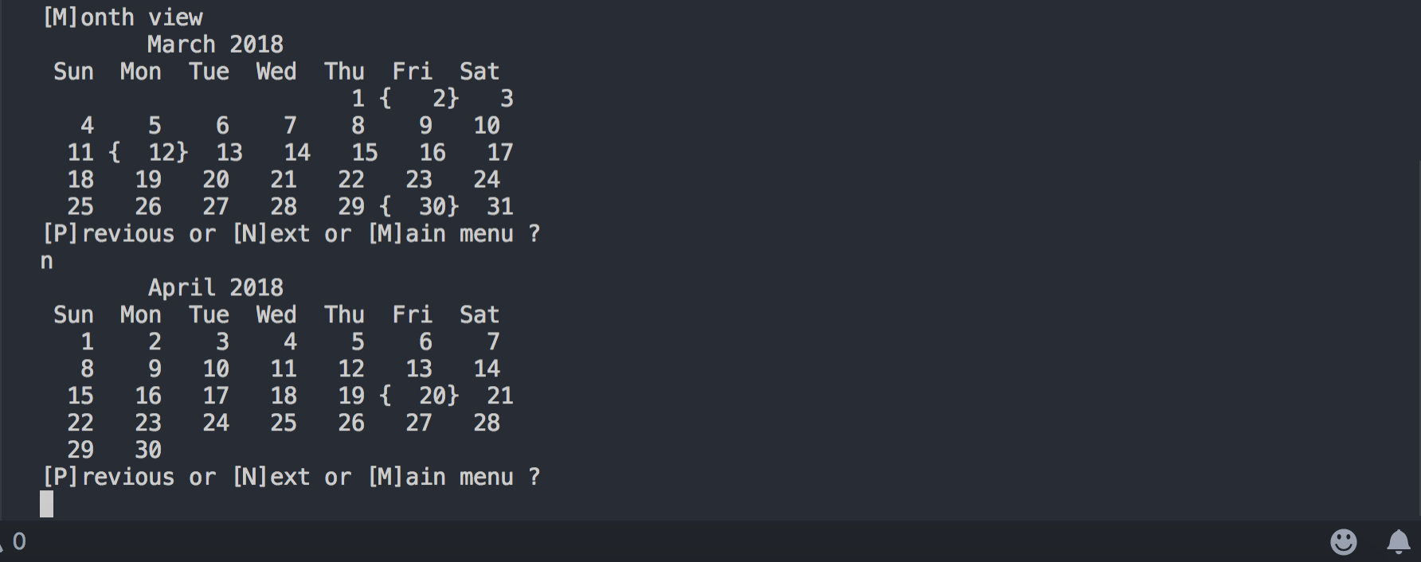

Screen 9: Select [C]reate and create an event. Show [E]vent list to confirm that the event is created.

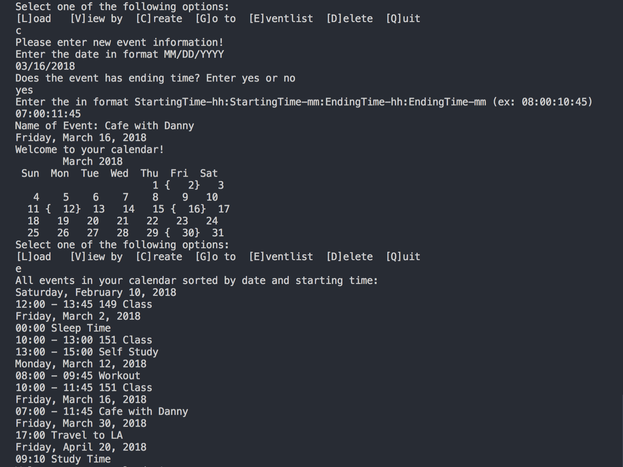

Screen 10: Select [C]reate and create an event with time conflict. Show you handled the time conflict.

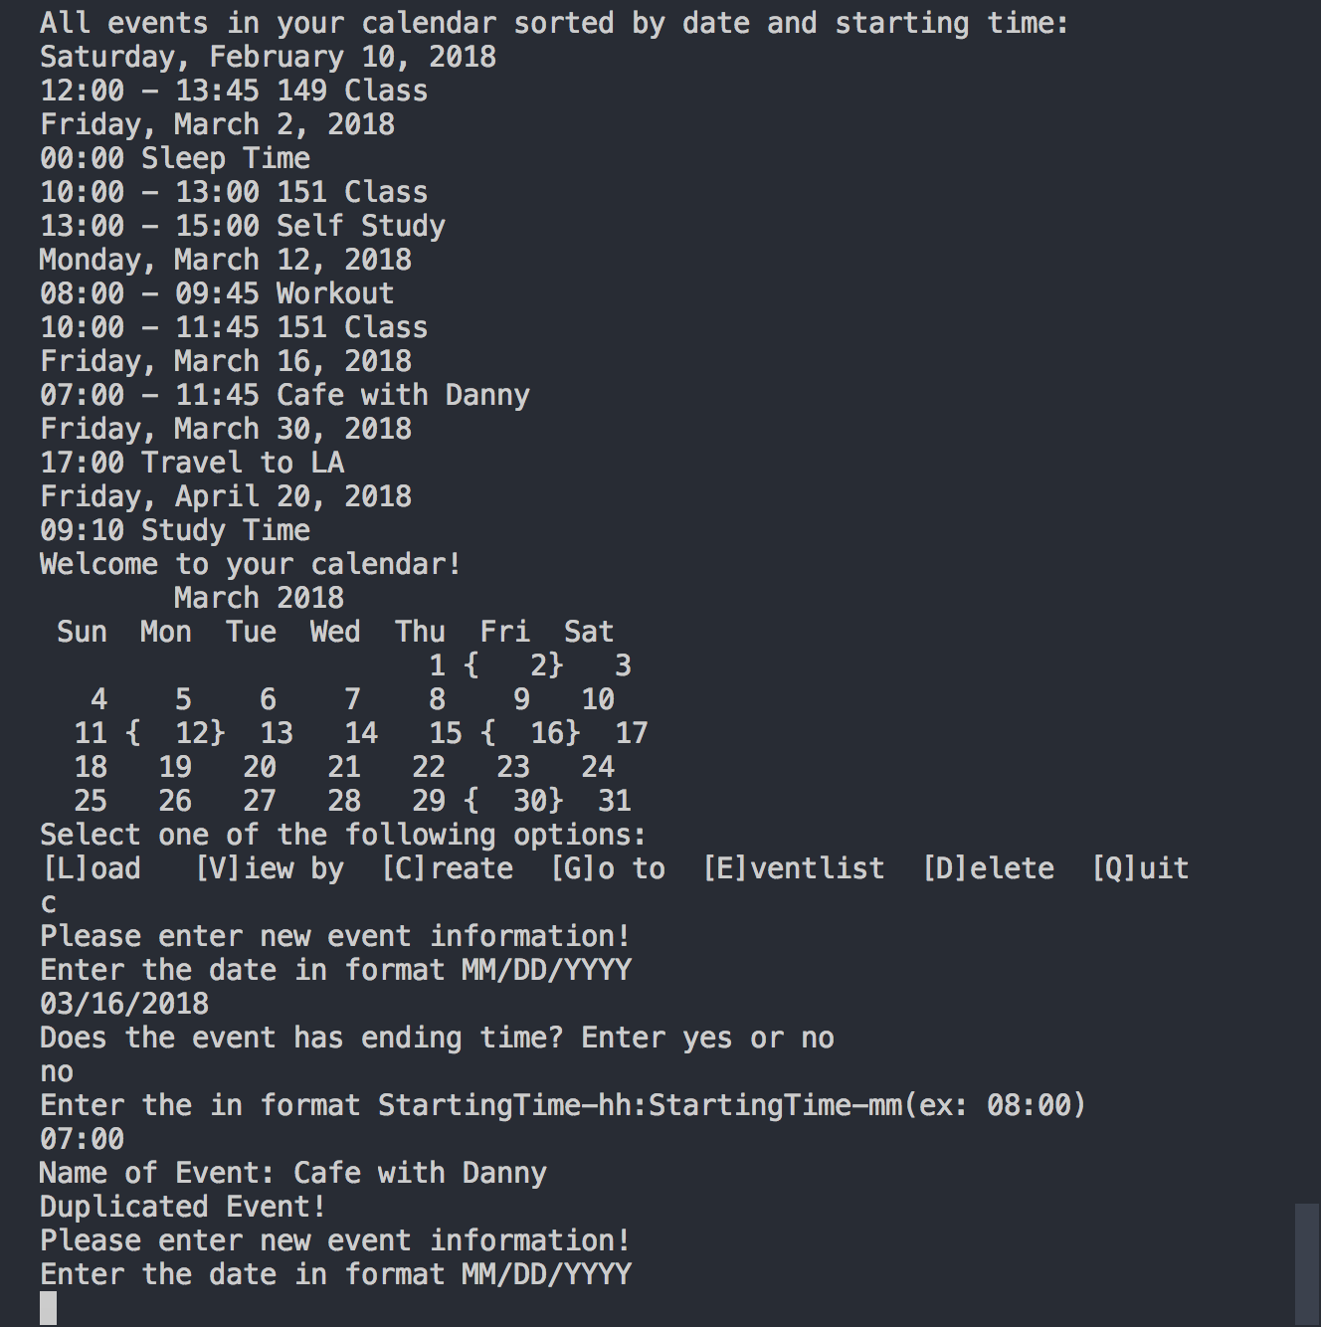

Screen 11: [G]o to a specific date with multiple events and show the events are listed in order.

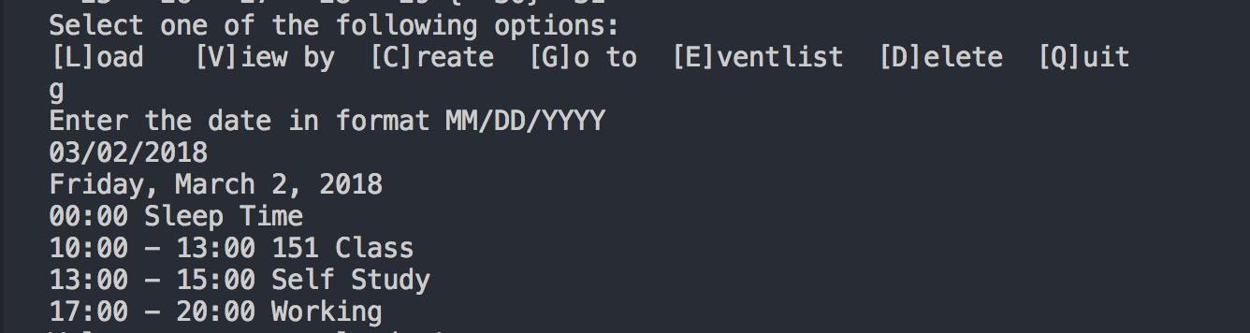

Screen 12: Select [D]elete and [S]elected to delete a selected event scheduled on a particular date. After deleting it, doe [E]vent list to show the result of the deletion.

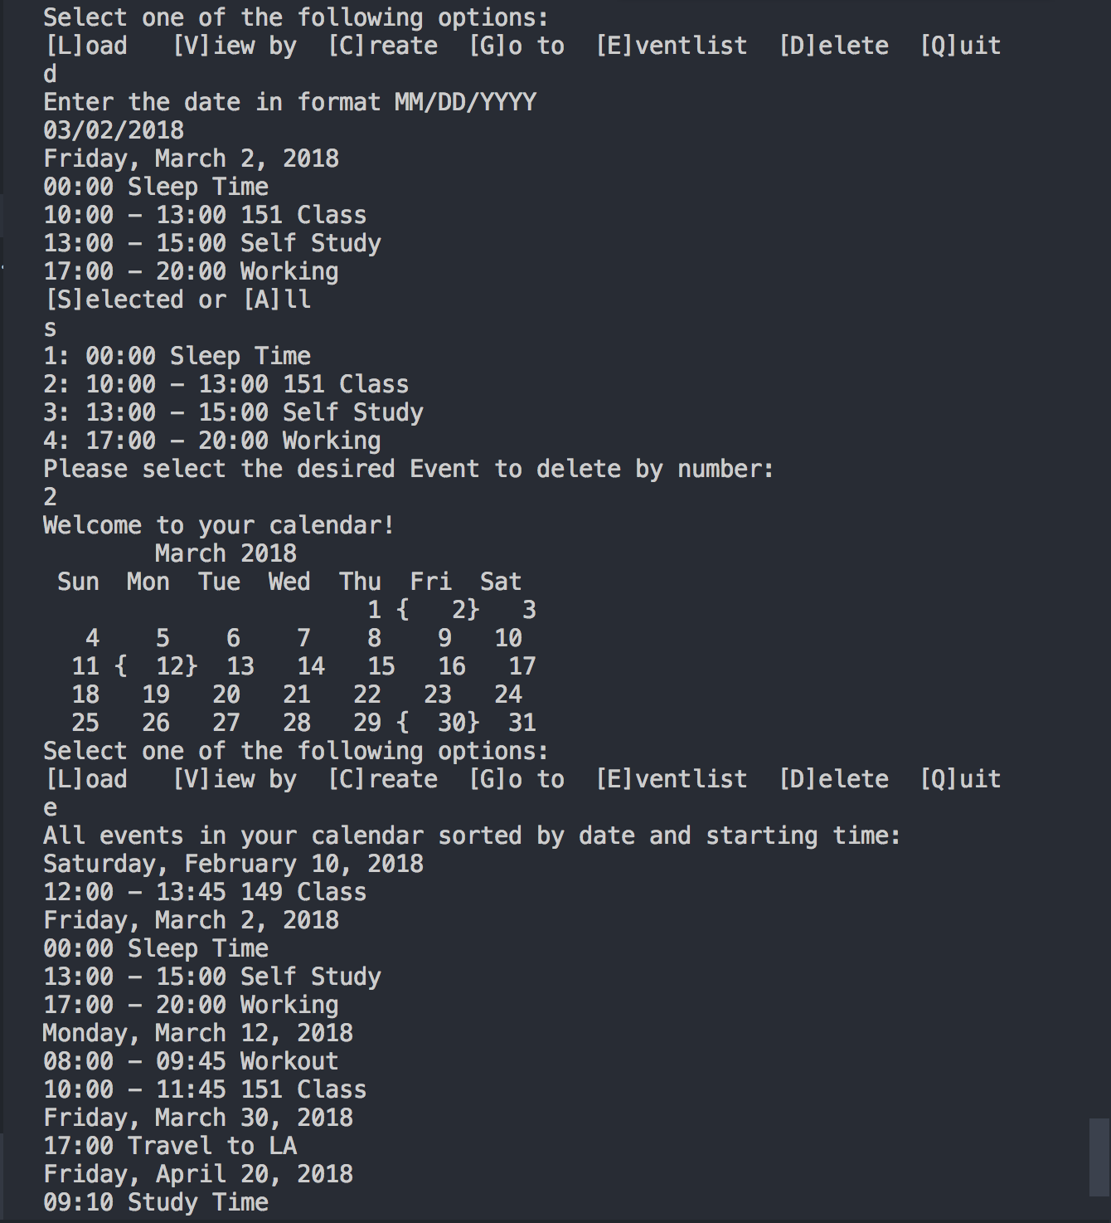

Screen 13: Select [D]elete and [A]ll to delete all events on a particular date. After deleting it, doe [E]vent list to show the result of the deletion.

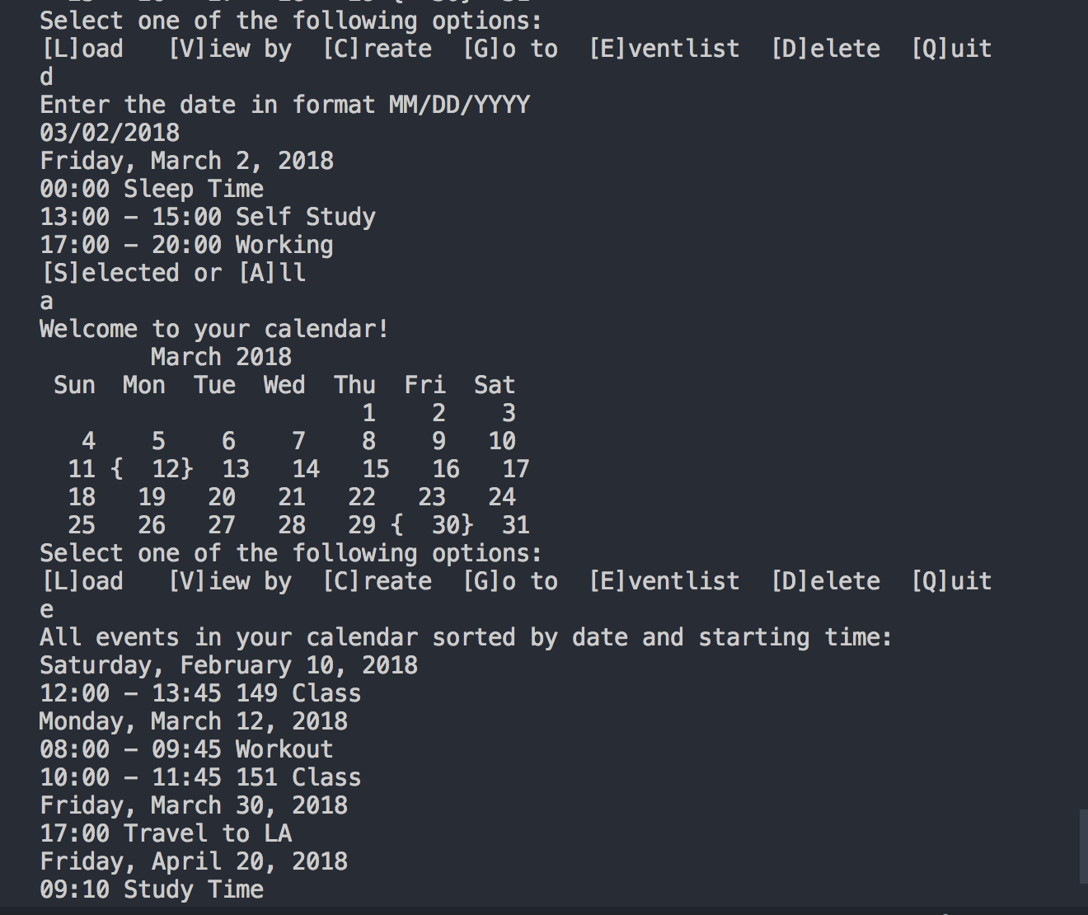

Screen 14: Create two more events and quit. Show your events.txt.

* Because I use serialization, so I don’t have events.txt. I created 2 new events then quit the program. Then I run the program again and run load. 2 new events still appeared.

